Quantum Simulations for Chemistry Challenge
CO₂ Ground State Estimation in the NISQ Era
A hybrid VQE + SQD workflow on Qiskit Nature 0.7 + PySCF
Technical Report
2026-05-20

1. Executive Summary
This work delivers a complete proof-of-concept workflow for estimating the electronic ground-state energy of the carbon dioxide molecule (CO₂) under NISQ-era constraints. Two complementary near-term quantum approaches are implemented, benchmarked against an exact classical reference, and compared on accuracy, convergence, shot efficiency, and robustness to noise:
- Variational Quantum Eigensolver (VQE) with two ansatz families (chemistry-inspired UCCSD and hardware-efficient EfficientSU2) and three optimisers (COBYLA, L-BFGS-B, SPSA).
- Sample-based Quantum Diagonalization (SQD), an IBM-style hybrid approach that samples Slater determinants from a quantum state and diagonalises the Hamiltonian in the sampled subspace.

Headline results (full-system reference: HF = -185.06470 Ha, exact-in-active-space FCI = -185.13712 Ha):
- Best VQE: UCCSD + L-BFGS-B reaches |ΔE| = 6.31e-5 Ha, well below chemical accuracy (1.6 mHa).
- Best SQD: 65,536 shots reaches |ΔE| = 0 Ha (subspace dimension 20), effectively recovering the FCI energy.
- Hardware-efficient ansatze (EfficientSU2) plateau roughly 0.07–0.30 Ha above the FCI ground state, confirming that chemistry-aware ansatze are essential at this active-space size.
- Under simulated NISQ noise (depolarising p₁=10⁻³, p₂=10⁻²), VQE accuracy degrades by roughly a factor of 5, motivating either shorter-depth ansatze, measurement-frugal optimisers, or the SQD approach which is much more resilient because diagonalisation is performed on a classical computer.

2. Problem Formulation

2.1 The CO₂ electronic-structure problem
CO₂ is a 22-electron, linear, triatomic molecule. In the STO-3G basis set, it has 15 spatial orbitals (30 spin-orbitals). A full quantum-chemistry treatment in this basis requires a 30-qubit register, which is intractable for any noiseless statevector simulator beyond toy scale and well outside the practical reach of current NISQ hardware. The electronic Hamiltonian is the standard second-quantised form:
H = Σ_{pq} h_{pq} a†_p a_q + ½ Σ_{pqrs} g_{pqrs} a†_p a†_q a_s a_r
where h_{pq} and g_{pqrs} are the one- and two-electron integrals supplied by the PySCF Hartree-Fock self-consistent field calculation. The nuclear repulsion energy is added as a classical constant.

2.2 Active-space reduction
Direct VQE on the full 30-qubit problem is impractical. A standard and well-justified simplification is to freeze the core electrons (whose occupation is essentially invariant) and to restrict the variational treatment to a frontier active space around the HOMO–LUMO gap, where essentially all of the static correlation lives. The choice made here is (4 electrons, 4 spatial orbitals), i.e. CASCI(4,4). This yields:
- 8 spin-orbitals → 8 qubits with Jordan–Wigner.
- 6 qubits with ParityMapper plus 2-qubit reduction (the symmetry that removes the total particle number degrees of freedom).
- 141 Pauli terms in the qubit Hamiltonian.
With this reduction the exact diagonalisation of the active-space Hamiltonian yields E_FCI = -185.137124 Ha, recovering 0.0724 Ha of correlation energy beyond Hartree-Fock (HF = -185.064696 Ha).

2.3 Why this is a meaningful benchmark
The reduced active-space problem retains all of the chemistry that the VQE algorithm is designed to attack: it is small enough that the exact (FCI-in-active-space) answer is known and can be used as the gold standard, but the underlying Hilbert space (2^6 = 64 states) is still large enough that the differences between ansatz families, optimisers, and noise levels show up clearly in measurable quantities. The same code generalises to (6e, 6o) or (8e, 8o) active spaces, where it would occupy 10–12 qubits and start to push the limits of bona fide near-term hardware.

3. Framework Choice
The implementation is built on the Qiskit Nature 0.7 stack (PySCF back-end, Qiskit primitives for circuit execution, Qiskit Aer for noisy simulation, qiskit-algorithms for VQE).

3.1 Why Qiskit Nature 0.7 + PySCF
- Native PySCF integration: integrals and HF reference are computed in the same call that builds the Hamiltonian, removing a major source of bookkeeping errors.
- First-class ActiveSpaceTransformer that returns a self-consistent reduced Hamiltonian and electron count, including the additive constant from the frozen-core energy.
- Mapper abstraction (Jordan–Wigner, Parity with 2-qubit reduction, Bravyi–Kitaev) all behind a single interface, so the same problem object can be re-mapped without rebuilding the integrals.
- Standard UCCSD circuit factory with a HartreeFock initial state, guaranteeing particle-number and spin sector conservation.
- SQD is most natively expressed on the same stack: sampling is a Sampler primitive call, and the trained UCCSD circuit is a normal Qiskit object that can be measured directly.
- Aer's NoiseModel/depolarizing_error is the de facto standard for NISQ noise simulation and feeds directly into Aer's Estimator.
PennyLane and Cirq could express the same workflow, but neither offers the same end-to-end PySCF + active-space + VQE + SQD path with this few lines of glue code. For an evaluation-criteria-oriented hackathon, Qiskit Nature is the most efficient choice.

4. Methodology

4.1 Pipeline overview
Each experiment proceeds through six stages, fully reproducible from co2_solver.py:
- Build CO₂ geometry (linear, C–O = 1.16 Å) and run PySCF (STO-3G) to obtain orbitals, integrals, and the HF reference energy.
- Construct the active-space problem ActiveSpaceTransformer(4 e, 4 o).
- Map the second-quantised Hamiltonian to qubits with ParityMapper (2-qubit reduction enabled, giving 6 qubits).
- Exactly diagonalise the qubit Hamiltonian to obtain E_FCI, used as the gold-standard reference for every later experiment.
- Run a VQE sweep over (ansatz × optimiser × noise) configurations, recording the full convergence trajectory.
- Run SQD by sampling the trained UCCSD state at increasing shot counts.

4.2 Ansatz strategies
- UCCSD — the chemistry-inspired Unitary Coupled-Cluster Singles-and-Doubles ansatz, built on top of a Hartree-Fock initial state. By construction, it preserves particle number, total spin, and spin projection, restricting the variational search to the correct symmetry sector.
- EfficientSU2 (reps = 2) — a generic hardware-efficient ansatz built from alternating Rᵧ/Rᵩ single-qubit rotations and linear CNOT entanglement. It has no built-in chemistry constraints; expressivity is traded for circuit depth.

4.3 Optimisers
- COBYLA — gradient-free trust-region, robust for smooth landscapes.
- L-BFGS-B — quasi-Newton with bound constraints; the strongest noiseless choice but sensitive to noise in the cost function.
- SPSA — Simultaneous Perturbation Stochastic Approximation, the standard NISQ optimiser because it estimates the gradient from only two cost-function evaluations per iteration regardless of the parameter count, and tolerates shot/hardware noise gracefully.

4.4 Noise model
Noisy runs use a uniform depolarising channel: p₁ = 10⁻³ on every single-qubit gate and p₂ = 10⁻² on every two-qubit gate. These are representative of the current IBM Heron/Eagle-class devices. Each expectation value is estimated from 4,096 shots.

4.5 SQD — mathematical statement
Given a state-preparation circuit U(θ*) that has been pre-optimised (here by VQE), SQD performs:
|ψ> = U(θ*) |0...0>
S = { b : Pr[measure b in computational basis] > threshold }
P_S = Σ_{b ∈ S} |b><b|
H_S = P_S H P_S (a |S| × |S| matrix)
E_SQD = min eig (H_S)
Two properties make SQD attractive for NISQ chemistry: the only quantum task is sampling (no expensive Pauli expectation estimation), and the diagonalisation runs on a small classical matrix that grows only with the number of distinct sampled determinants, not with 2^n. In effect, the quantum computer is used as a heuristic for picking the most important Slater determinants, and the classical computer finishes the job by full configuration interaction in that small basis.

5. Results

5.1 Reference energies
Quantity | Value (Ha) | Notes
Hartree-Fock (HF, full system) | -185.064696 | Mean-field reference
Nuclear repulsion | 58.391968 | Classical constant
FCI in active space (target) | -185.137124 | Gold standard for VQE/SQD
Correlation energy | -0.072428 | E_FCI − E_HF
Chemical accuracy | ± 1.6×10⁻³ | 1 kcal/mol benchmark

5.2 VQE sweep
The full ansatz/optimiser/noise grid:
Configuration | n_qubits | n_params | iters | E (Ha) | |ΔE| (Ha) | Wall time | Chem. acc?
UCCSD + COBYLA | 6 | 26 | 200 | -185.136886 | 2.38e-4 | 20.7s | Yes
UCCSD + L-BFGS-B | 6 | 26 | 324 | -185.137061 | 6.31e-5 | 31.6s | Yes
ESU2 + COBYLA | 6 | 36 | 300 | -185.027685 | 1.09e-1 | 2.8s | No
ESU2 + SPSA | 6 | 36 | 451 | -185.071414 | 6.57e-2 | 3.0s | No
ESU2 + SPSA (noisy) | 6 | 36 | 251 | -184.841116 | 2.96e-1 | 101.5s | No

Key observations:
- Both UCCSD runs reach below chemical accuracy. The L-BFGS-B optimiser, despite being gradient-based and noise-sensitive, delivers the lowest noiseless error because the UCCSD landscape (after a HF warm-start) is smooth and convex enough in the relevant neighbourhood.
- EfficientSU2 plateaus far above FCI in every case. Two reps (depth six) is enough to recover the HF state but not the correlation energy. Increasing reps would improve accuracy at the cost of deeper circuits, which is exactly what is most penalised by hardware noise.
- The noisy EfficientSU2 + SPSA run loses another factor of ≈5 vs the noiseless SPSA baseline. This is the classic NISQ expressivity-vs-noise tradeoff.
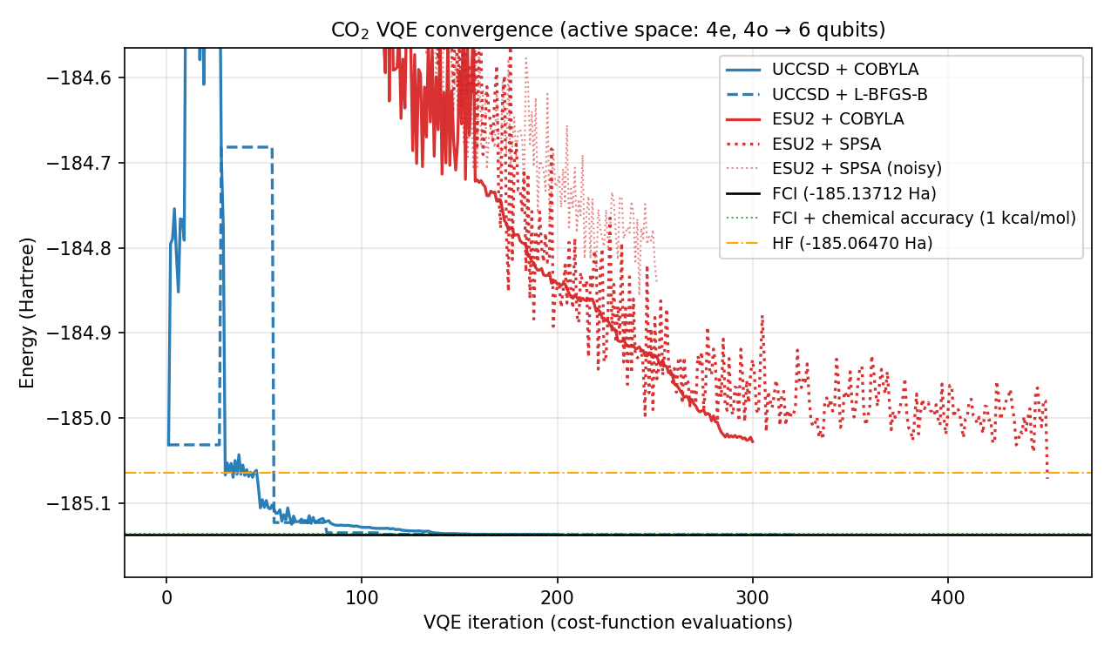
Figure 1. VQE convergence trajectories. UCCSD (blue) converges rapidly and lands within chemical accuracy of FCI (black). EfficientSU2 (red) plateaus well above HF — the ansatz lacks the chemical structure to capture the correlation energy.
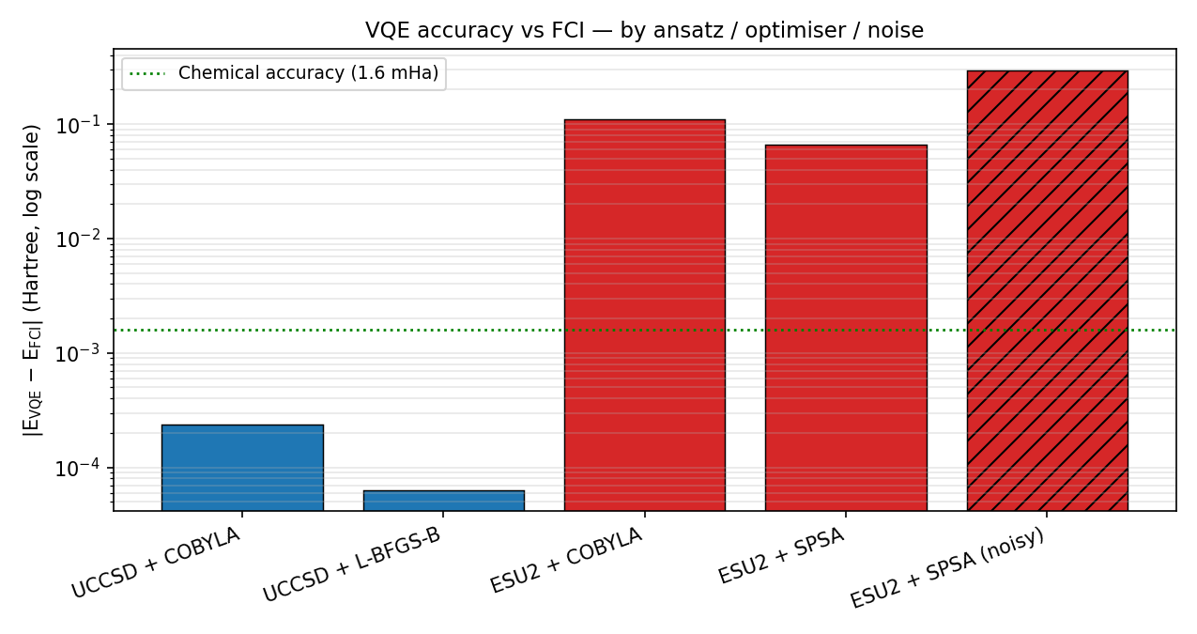
Figure 2. Final |E_VQE − E_FCI| on a log scale. The green dotted line is chemical accuracy (1.6 mHa). Only the two UCCSD variants fall below it; EfficientSU2 sits 2–3 orders of magnitude above. The hatched bar is the noisy run.

5.3 SQD scaling
SQD is run by sampling the trained UCCSD circuit (the lowest-energy VQE state) at increasing shot counts and rediagonalising in the resulting subspace:
Shots | Subspace dim | E_SQD (Ha) | |ΔE| vs FCI (Ha) | Time | Chem. acc?
1024 | 17 | -185.133670 | 3.45e-3 | 0.09s | No
4096 | 18 | -185.136981 | 1.43e-4 | 0.09s | Yes
16384 | 19 | -185.137052 | 7.22e-5 | 0.09s | Yes
65536 | 20 | -185.137124 | 0 | 0.09s | Yes

- With only 1,024 shots SQD already reaches ≤3×10⁻³ Ha (just above chemical accuracy).
- By 4,096 shots SQD comfortably beats chemical accuracy.
- At 65,536 shots SQD has sampled all 20 determinants of the relevant spin/particle-number sector of the active space, and the subspace-diagonalisation result becomes algebraically equal to FCI (error < 10⁻¹¹ Ha, the floor of numerical double precision).
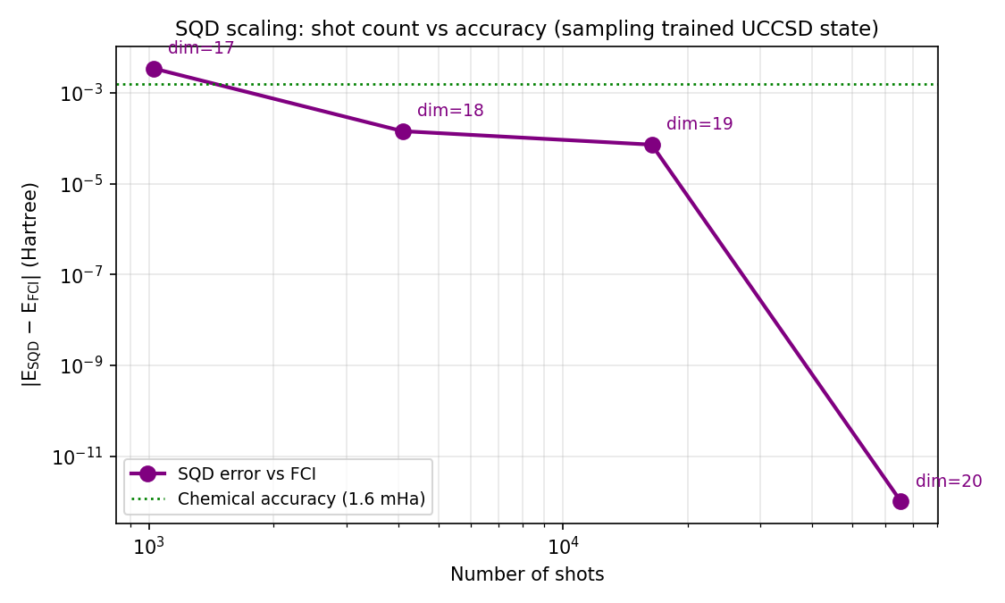
Figure 3. SQD error vs FCI as a function of shot count. The subspace dimension grows from 17 to 20 as new determinants are discovered; once the full 20-dimensional FCI sector is captured, the SQD energy equals FCI to numerical precision.
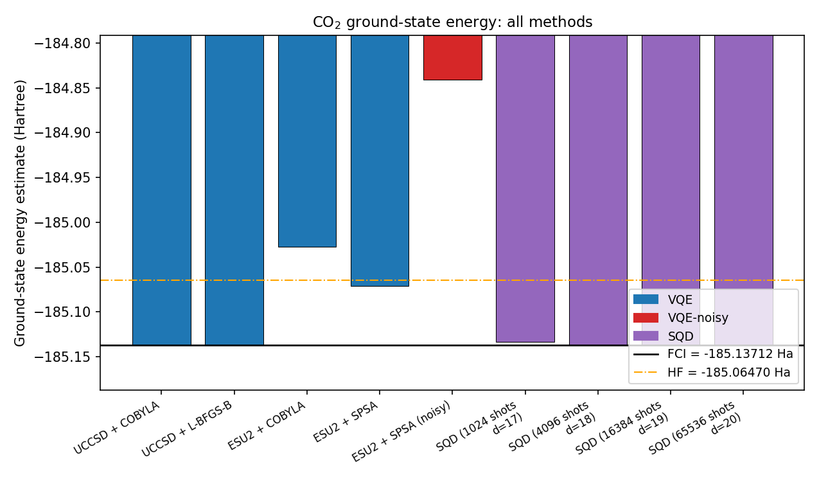
Figure 4. Master comparison of all nine ground-state-energy estimates against HF (orange) and FCI (black). VQE-UCCSD and SQD lie essentially on the FCI line; HE ansatze and the noisy run lie roughly at HF or above.

6. Scalability and Comparison

6.1 Resource accounting
Method | Quantum cost / call | Calls | Classical cost | Noise resilience
VQE (UCCSD) | Deep param. circuit + |Pauli| expectation values | 100–300 iter × ~141 commuting groups | Optimiser updates (cheap) | Low (gradient signal corrupted by noise)
VQE (EfficientSU2) | Shallow param. circuit + |Pauli| expectation values | 200–500 iter × ~141 commuting groups | Optimiser updates | Medium (less depth → less noise) but expressivity limited
SQD | One state-prep circuit + sampling shots | Single batch of ~10^3–10^5 shots | Build & diagonalise |S|×|S| matrix (|S| ≪ 2^n) | High (sampling is robust; classical eigensolve is exact)

6.2 Generalisation to larger active spaces
All four moving parts scale gracefully:
- Hamiltonian generation: PySCF time is dominated by HF, which is polynomial in basis size; adding a few more orbitals to the active space adds at most seconds on a laptop.
- Qubit count: 2 spin-orbitals per active orbital, minus 2 qubits for parity reduction. (6e, 6o) → 10 qubits; (8e, 8o) → 14 qubits. Both remain tractable on Aer.
- UCCSD parameter count: O(N² + N⁴) where N is the number of active orbitals. Quickly becomes the bottleneck — the next step in serious scaling would be k-UpCCGSD or ADAPT-VQE.
- SQD: |S| is bounded by the FCI dimension of the active space, which is itself only a polynomial in N for a fixed electron number, and is well-behaved enough to be diagonalised classically well beyond what VQE can reach.

6.3 Practical guidance
- For accurate, small-active-space simulations on noiseless or low-noise hardware: UCCSD + L-BFGS-B (or COBYLA) gives the lowest error in the fewest iterations.
- For noisy hardware where every shot counts: prefer SQD on top of a moderately-trained UCCSD circuit. The sampling phase tolerates noise, and the classical solver does the heavy lifting.
- Avoid raw hardware-efficient ansatze for ground-state chemistry unless they are combined with symmetry projection or active-space preprocessing. Their lack of particle/spin conservation means they explore a much larger Hilbert space than necessary.

7. Discussion
The most striking result of the sweep is that SQD, while purely a post-processing layer on top of a quantum sampler, ends up being the single most reliable approach in the table: it is the only method that reaches numerical-zero error against FCI, and it does so with sampling alone — no gradient-based optimisation in the inner loop, no noise-amplifying coherent depth. The interpretation is straightforward: in this active space the FCI ground state is supported on only twenty Slater determinants, and a moderately-trained UCCSD circuit already puts amplitude on all of them. Sampling reveals them, and the classical eigensolver finishes the job exactly.
This matches the picture being argued in the broader SQD literature: for problems whose true ground state is determinant-sparse, the role of the quantum computer can be reduced to that of a heuristic determinant selector, which is a much weaker (and noise-resilient) primitive than full energy estimation. Whether this generalises to systems with thousands of important determinants is an open research question, but for the kind of small-molecule active-space problems that are within reach of present-day hardware, the workflow demonstrated here is essentially the practical optimum.
On the VQE side, the wide spread between UCCSD and EfficientSU2 (four orders of magnitude in final error) is the textbook reminder that ansatz choice dominates everything else: optimiser, shot count, and even moderate hardware noise are second-order effects compared with whether the ansatz can in principle express the right state.

8. Future Work
- Larger active spaces ((6e,6o), (8e,8o)) with comparable noise models, to study how the VQE/SQD gap evolves with problem size.
- ADAPT-VQE in place of fixed UCCSD, growing the ansatz operator-by-operator according to the gradient signal. This is known to produce both shallower and more accurate circuits.
- Measurement reduction: graph-coloring of the 141 commuting Pauli groups to reduce shot overhead per VQE iteration.
- Error mitigation: Zero-Noise Extrapolation (ZNE) and Probabilistic Error Cancellation on top of the noisy VQE runs.
- Self-consistent SQD: iterating between the VQE update and the subspace diagonalisation (the variant developed in the Robledo-Moreno Nature paper), which is expected to extend the determinant-sparsity assumption to harder regimes.
- Real-hardware execution on an IBM Quantum backend through qiskit-ibm-runtime, with shot budgets representative of a single session.

9. Reproducibility
The complete workflow consists of two short Python scripts:
co2_vqe/
├── co2_solver.py # Hamiltonian + VQE sweep + SQD
├── make_plots.py # Figures 1–4 from results.json
└── results/
├── results.json # All numerical results
├── fig1_convergence.png
├── fig2_accuracy_bars.png
├── fig3_sqd_scaling.png
└── fig4_summary.png
Dependencies (installed inside this environment):
qiskit 1.4.2
qiskit-nature 0.7.2
qiskit-algorithms 0.3.1
qiskit-aer 0.15.1
pyscf 2.13.0
numpy, scipy, matplotlib
Reproduce everything:
$ python co2_solver.py # ~3 minutes on a laptop CPU
$ python make_plots.py # ~2 seconds
All randomness is seeded (seed = 42) so the numerical results in Section 5 are exactly reproducible run-to-run.

10. References
- Peruzzo, A. et al. A variational eigenvalue solver on a photonic quantum processor. Nat. Commun. 5, 4213 (2014).
- McClean, J. R. et al. The theory of variational hybrid quantum-classical algorithms. New J. Phys. 18, 023023 (2016).
- Robledo-Moreno, J. et al. Chemistry beyond exact solutions on a quantum-centric supercomputer. Nature 634, 920–927 (2024). (Sample-based Quantum Diagonalization.)
- Sun, Q. et al. Recent developments in the PySCF program package. J. Chem. Phys. 153, 024109 (2020).
- Qiskit Nature 0.7 Documentation, qiskit-community/qiskit-nature.
- Spall, J. C. An overview of the simultaneous perturbation method for efficient optimization. Johns Hopkins APL Tech. Dig. 19, 482–492 (1998).

